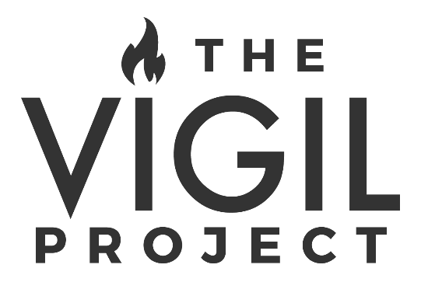
The Vigil Project is a Community of musical artists that was formed in January 2016. Featuring a collective of seasoned singer/songwriters and worship leaders (Andrea Thomas, John Finch, Shawn Williams, and Greg&Lizzy), TVP exists to invite the Church to a fresh encounter with God and to deep prayer through the experience of beautiful music. In less than two years, they’ve quickly garnered international acclaim through the release of two music video series’ (“Lent and Easter” and “Advent and Christmas”) that have helped set a new standard globally for quality in the Catholic music industry. TVP maintains a seasonal touring schedule between producing new music/film projects and finding creative ways to invite and unite the universal Church in prayer.

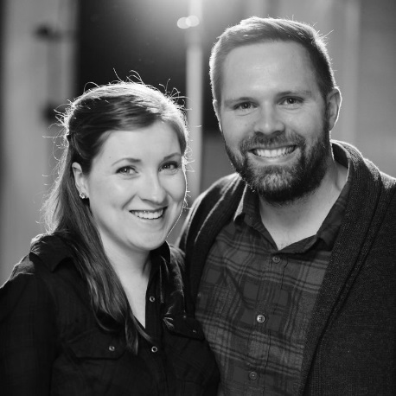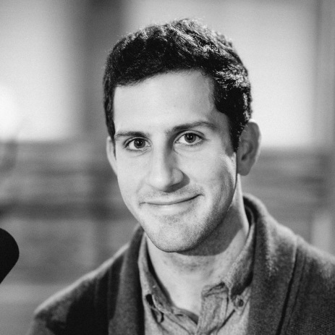
GREG&LIZZY JOHN FINCH ANDREA THOMAS
VOCALISTS + SONGWRITERS VOCALIST + SONGWRITER VOCALIST + SONGWRITER
+ ACOUSTIC GUITAR + PIANO

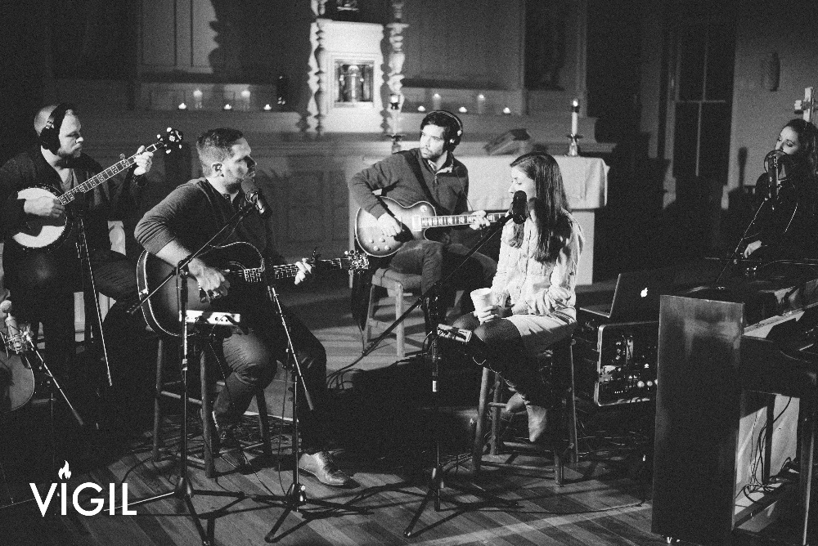

The event will feature live music, dynamic speaking, and prayer all aimed at telling the story of the depth of God’s love poured out through his Son Jesus, who came to “Seek and save the lost (Luke 19:10).” By offering this story through a multimedia program, the group hopes to bring it to life in a new way for those who are familiar with it and those who have never heard it before.

To learn more about The Vigil Project, watch the videos, and hear the music, visit www.thevigilproject.com.

